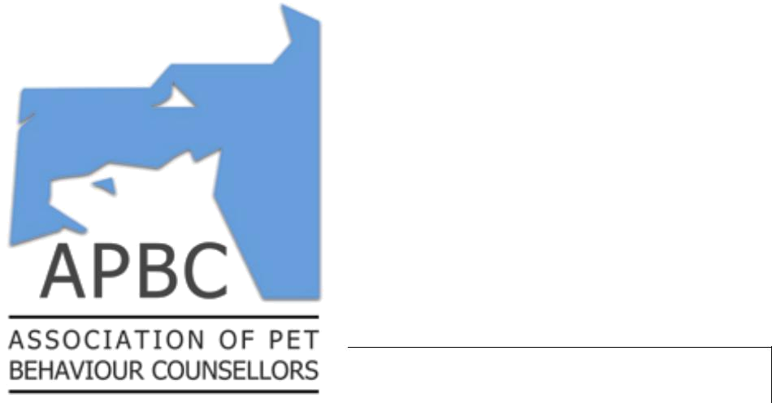

Referral form

Behaviour problems may arise both directly and indirectly as a result of concurrent or previous medical problems. Veterinary involvement is therefore essential in eliminating organic causes of the problem and prioritising the diagnostic and treatment strategy to be used in any given case. In order to safeguard the welfare of your patient and indicate your approval of referral, please complete the following form.

I hereby acknowledge my approval for the client and patient described on this form to be referred for management of the current behaviour problem to Mathew Ward:

Signed (vet):________________________________

Print Name:

Date:

As the owner of the named animal I consent to the disclosure of clinical information regarding my pet between my veterinary surgeon and Mathew Ward:

Signed (owner):______________________________

Print Name:

Date:

Client details:
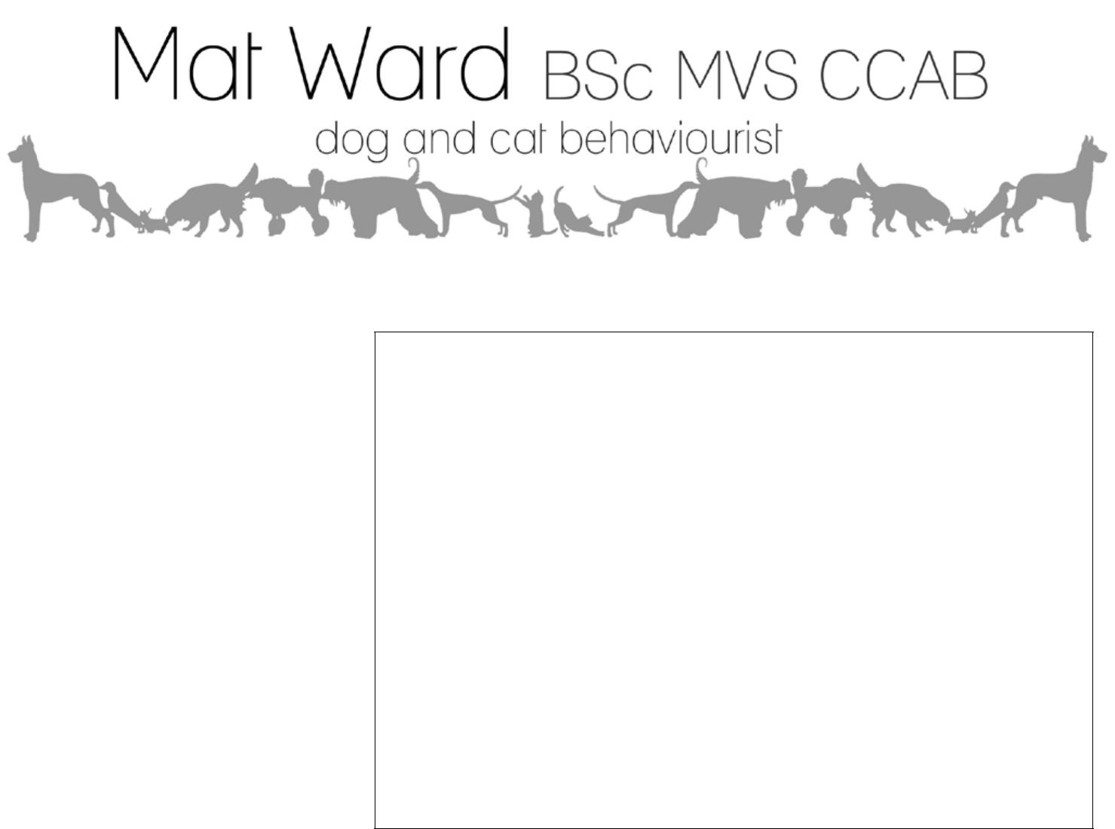

Client's name:

Patient’s name:

Species/breed:

Date of last health check: / /

Nature of behaviour problem:

Please tick appropriate box:

- Relevant medical history accompanies this slip.

- Relevant medical history supplied by post/phone/email.

- There is no relevant medical history

Veterinary surgeon details:

Referring veterinarian:

Practice name:

Telephone:

Email:

Address:

Postcode:

Phone: 01368 850314 Email: petbehavioursorted@gmail.com Web: www.petbehavioursorted.com

- What sort of problems can a member of the APBC help me with?

The range of behavioural problems treated by APBC members include, but are not limited to: aggression, fears and phobias, destructiveness, toileting problems, separation problems, marking, spraying, self -mutilation, barking, stereotypic behaviour, nervousness, car travel, livestock chasing, and general disobedience.

- How can a member of the APBC help me?

The treatment of behaviour problems requires someone with the knowledge, experience, skill, and time necessary to accurately establish the causes of a behaviour problem, and to develop a treatment plan that is suitable for the owner's circumstances.

The APBC represents a network of experienced behaviour counsellors who, on referral from veterinary surgeons, are able to offer the time and expertise necessary to achieve these objectives at an affordable cost.

- What happens at the time of the consultation?

Consultations are held on an appointment basis, normally in the client’s own home. They usually last 2 - 4 hours. If possible all family members involved should be present. A history of the problem will be taken, and the pet's behaviour assessed. After this the counsellor will explain the motivation for the behaviour and help to devise a treatment plan.

- What happens after the consultation?

Treatment plans vary accordi ng to the nature and severity of the problem. Often only one consultation is necessary. Further advice and aftercare will be provided via the telephone or email. Where treatment dictates it, a follow-up appointment can be arranged.

A report outlining the treatment plan will be sent to both client and veterinary surgeon.

For further information regarding a behaviour consultation please call Mat on 01368 850314, or go to www.petbehavioursorted.com

